FACT SHEET: Water Safety for Pets during Saltwater Intrusion

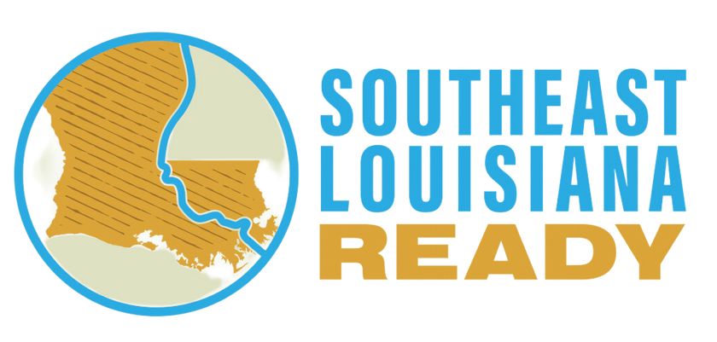

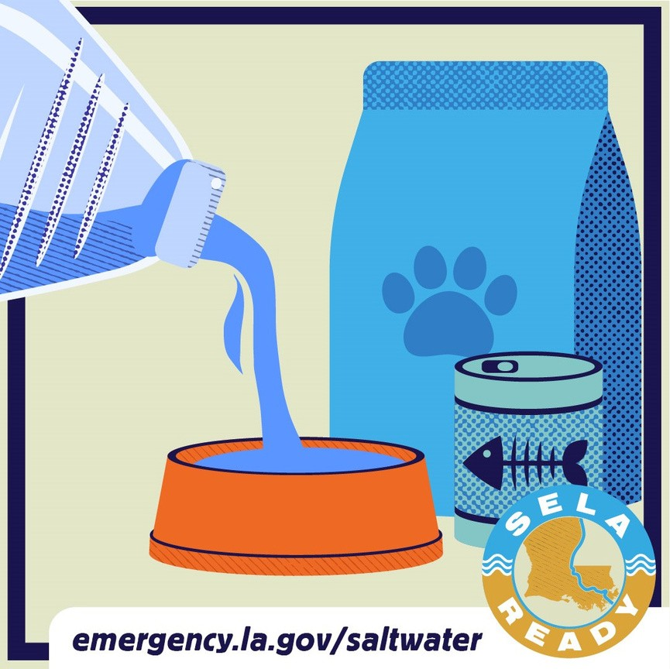Due to a lack of rainfall up north, the water levels of the lower Mississippi River are extremely low, allowing salt water from the Gulf of Mexico to come upstream. This phenomenon, known as saltwater intrusion, can affect local water supplies because many public drinking water systems in south Louisiana rely on fresh water from the Mississippi River.

The Louisiana Department of Health (LDH), along with regional, state and federal partners, is actively monitoring the situation and conducting water quality testing and analysis to provide regular updates to the general public and healthcare providers about impacts to water systems and necessary precautions.

We urge residents of the Southeast Louisiana parishes affected by the saltwater

intrusion to stay informed by signing up for their local text alert systems. Visit [emergency.la.gov/saltwater](http://emergency.la.gov/saltwater) to get the latest updates on the saltwater intrusion in southeast Louisiana.



**Salt water is unsafe for pets:**

Animals cannot safely consume water that contains high levels of salt.

If your water system is under a saltwater advisory (or “High Sodium Water Advisory”), pets should not be given tap water. Water systems will notify their customers of High Sodium Water Advisories. You can find the current list of High Sodium Water Advisories [here](https://ldh.la.gov/page/4595).



**Safe water sources for pets:**

Store-bought bottled water or water you bottle yourself from other municipal sources unaffected by the saltwater intrusion is fine for household pets.

At this time there is no need to stock up on more water than you need.



**Recommended water consumption for pets:**

Pets typically require about 1 ounce (about 30 ml) of water for each pound of bodyweight per day. So, an

8-pound animal needs 8 ounces of water per day, or about 1 gallon of water for one week. A 60-pound dog needs about a half-gallon of water per day, or about 4 gallons for one week.

Water requirements vary based on the animal’s age, the weather and stressors.

More active pets require more water, and animals need more water in warmer weather.



FACT SHEET: Water Safety for Pets during Saltwater Intrusion

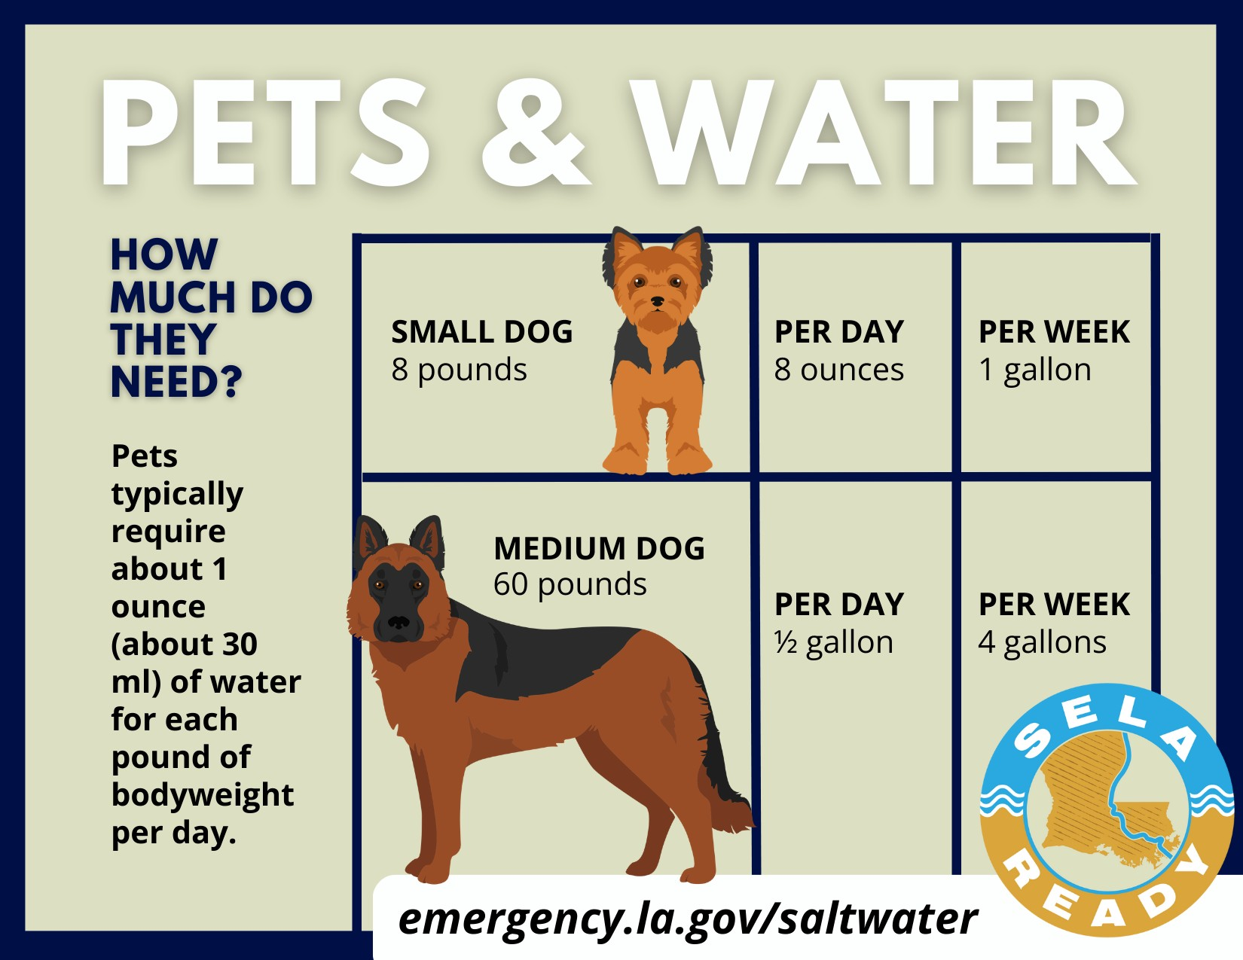



**Safe water storage:**

Use FDA-approved food-grade water storage containers. These FDA containers will not transfer toxic substances into the water, and they can be found at surplus or camping supply stores.

If you are unsure if a container is food-grade, contact the container manufacturer. Water storage containers should:

Have a top that can be closed tightly;

Be made of durable, unbreakable materials (not glass);

Have a narrow neck or opening so water can be poured out; and

Have never been used previously to hold liquid or bleach, pesticides or solid toxic chemicals.



**Additional information:**

[Creating and Storing an Emergency Water Supply | Water, Sanitation, & Hygiene-related Emergencies & and Outbreaks | Healthy Water | CDC](https://www.cdc.gov/healthywater/emergency/creating-storing-emergency-water-supply.html)